**Hands On Practice On Bash -:- 11-11-2022**

1 . Use of Echo Command ::



2 . Use of Read Command ::

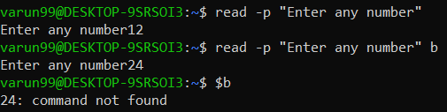

3.1 Using Bash to print a Line ::

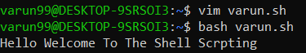

3.1(Bash)

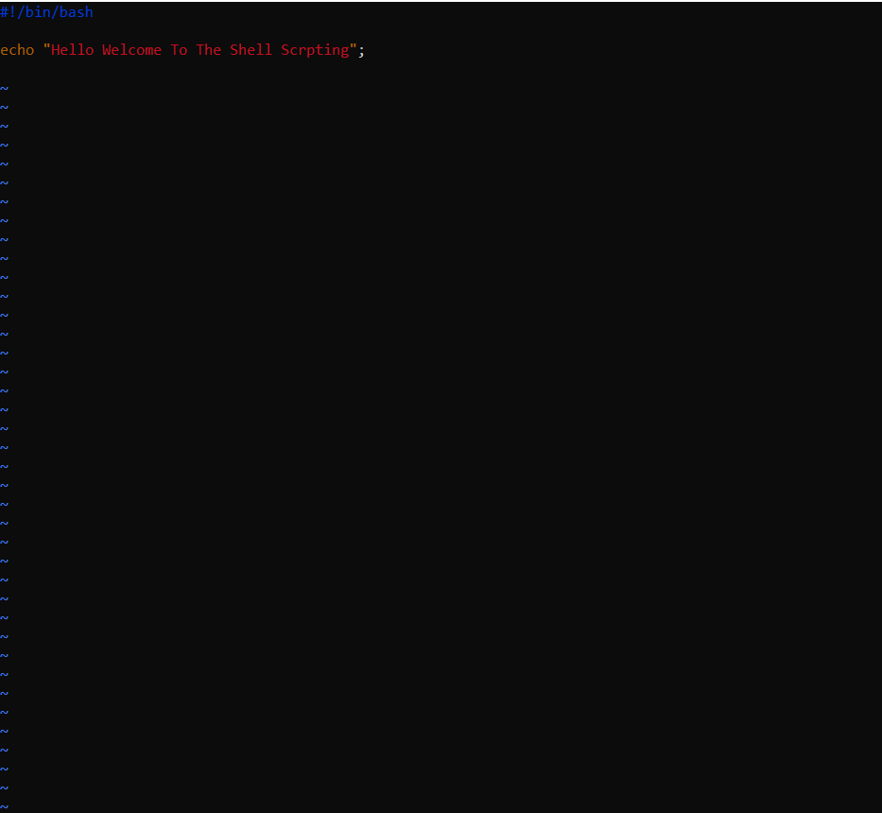

4.1 : To print the age :

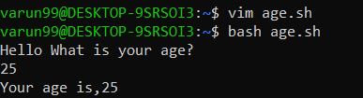

4.2 : On bash

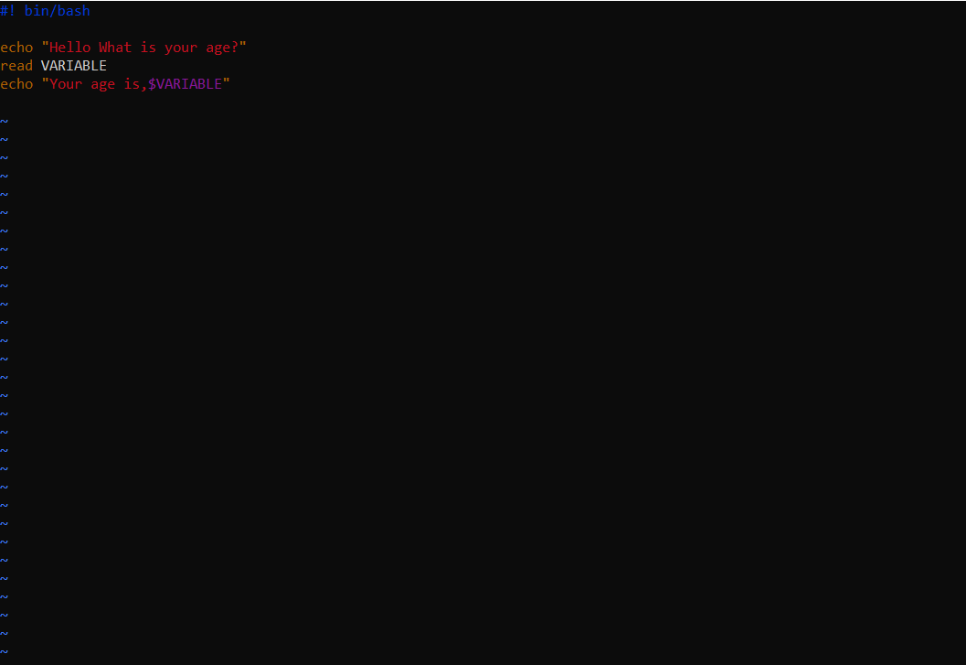

5.1 : Use of some maths terms :

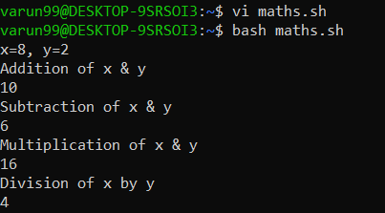

5.2 On bash

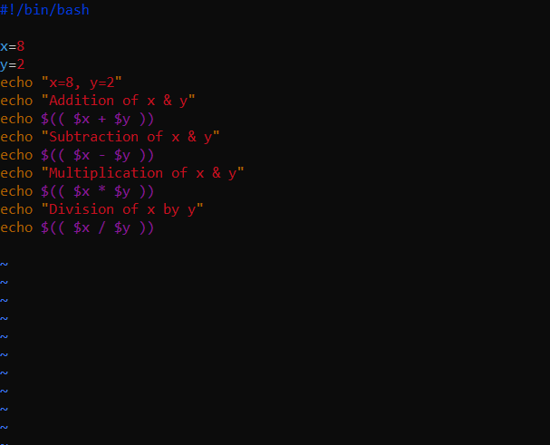

6.1 : Use of if-else :

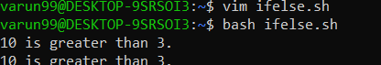

6.2 : On bash

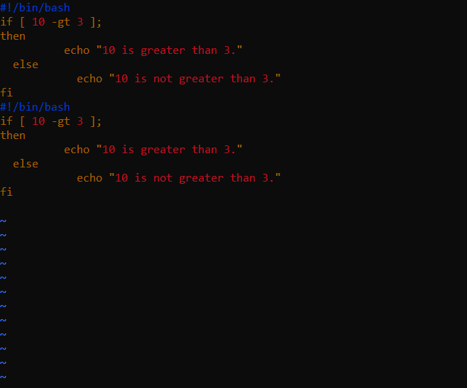

7.1 : Use of For-Loop :

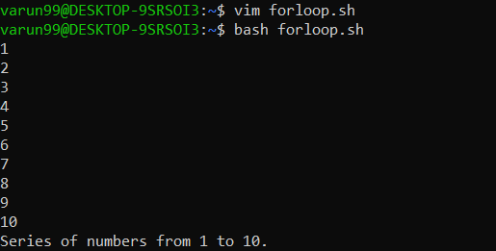

7.2 On Bash

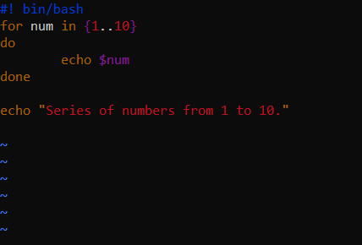

8.1 : Use of For and If together :

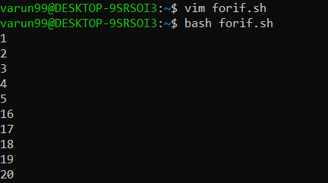

8.2 On Bash :

